EXP:8
Round Robin Scheduling
Note: Uses time quantum 2 and burst times 5, 4, 2.
CODE:
#include <stdio.h>
int main(void) {
int bt[] = {
5, 4, 2
}, rem[] = {
5, 4, 2
}, n = 3, q = 2, t = 0, i, done;
do {
done = 1;
for (i = 0; i < n; i++)
if (rem[i] > 0) {
done = 0;
if (rem[i] > q) {
t += q;
rem[i] -= q;
}
else {
t += rem[i];
rem[i] = 0;
printf("P%d completes at time %d\n", i + 1, t);
}
}
}
while (!done)
;
return 0;
}
OUTPUT:
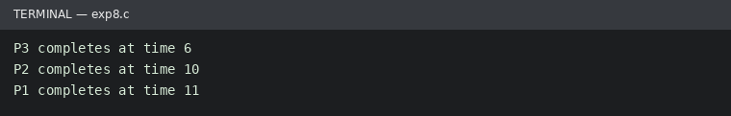
Run status: Ran successfully

